Task 1: Data Preprocessing & Cleaning
● Remove duplicate Tesla posts.
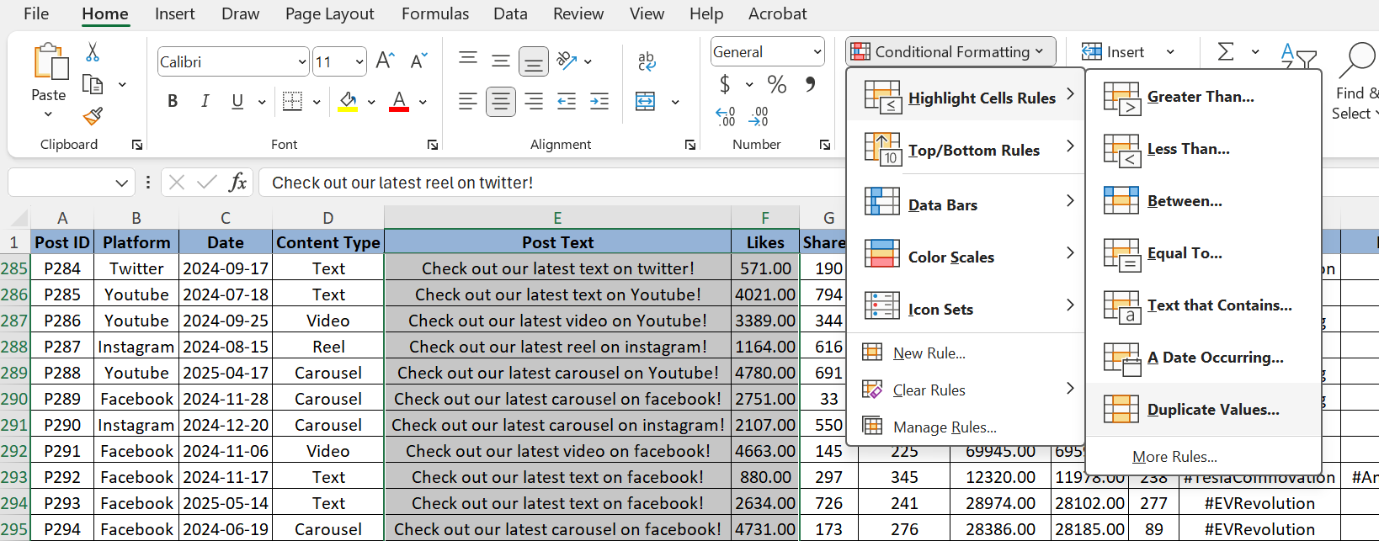
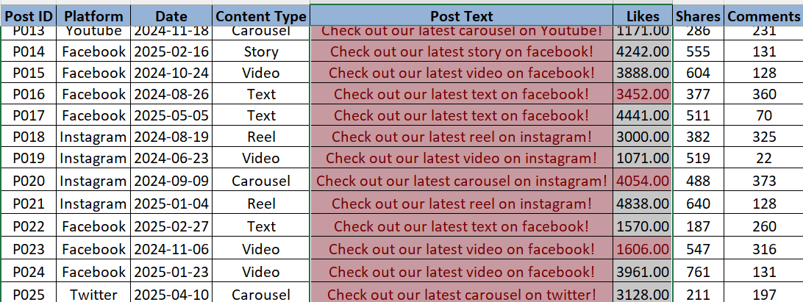
Checked the highlighted Likes value against the post text column and there are no duplicates.
● Standardize date & platform names.
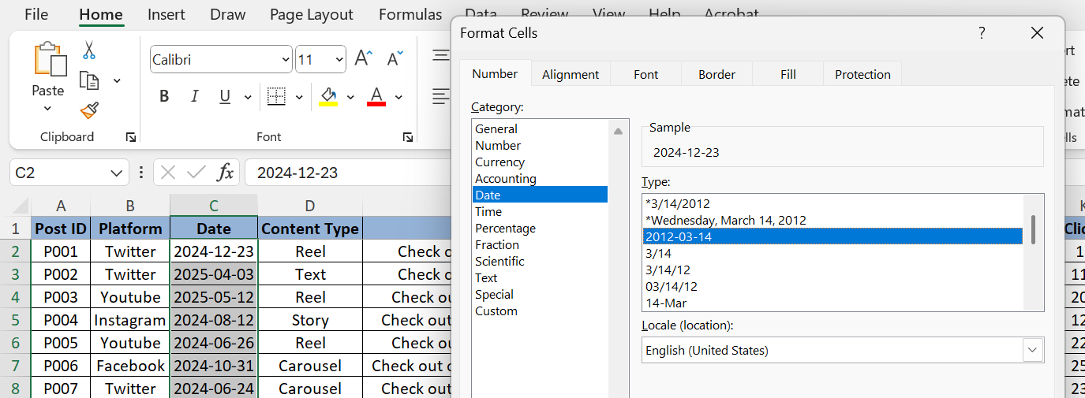
Clicked on the ‘Large date’ format under general for dates and for platform clicked ‘text’

● Format numeric columns (Likes, Reach, Impressions, Ad Spend).
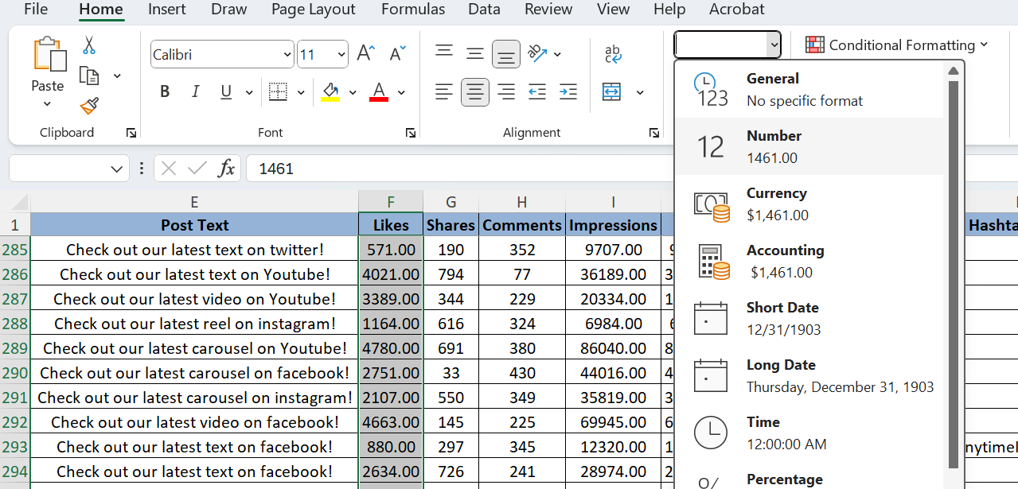
For Likes, Reach, Impressions click on the ‘Number’ and for the Adspend click on ‘Currency’
● Split hashtags (e.g., #Cybertruck, #EVRevolution, #TeslaEnergy) into individual tags.
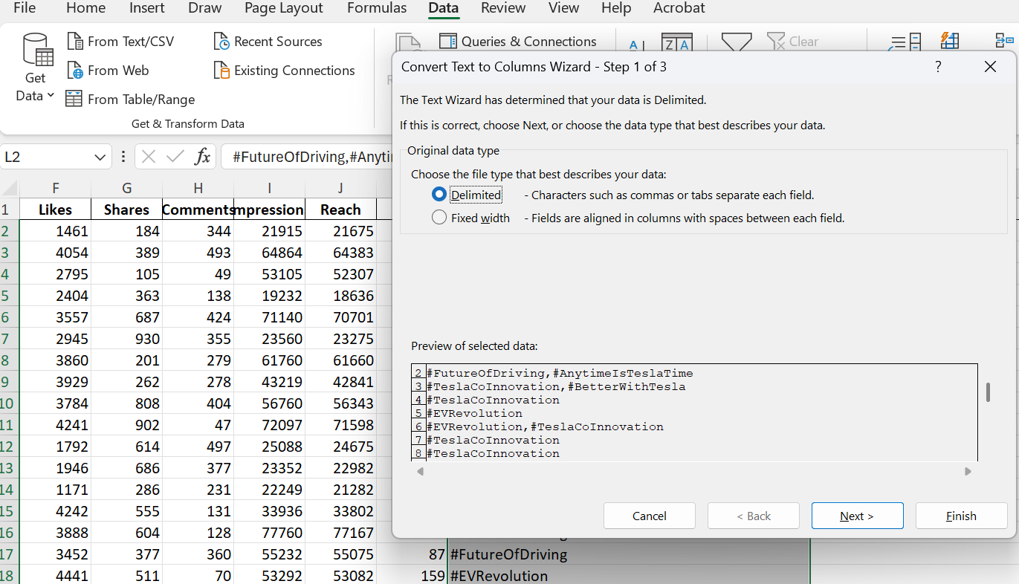

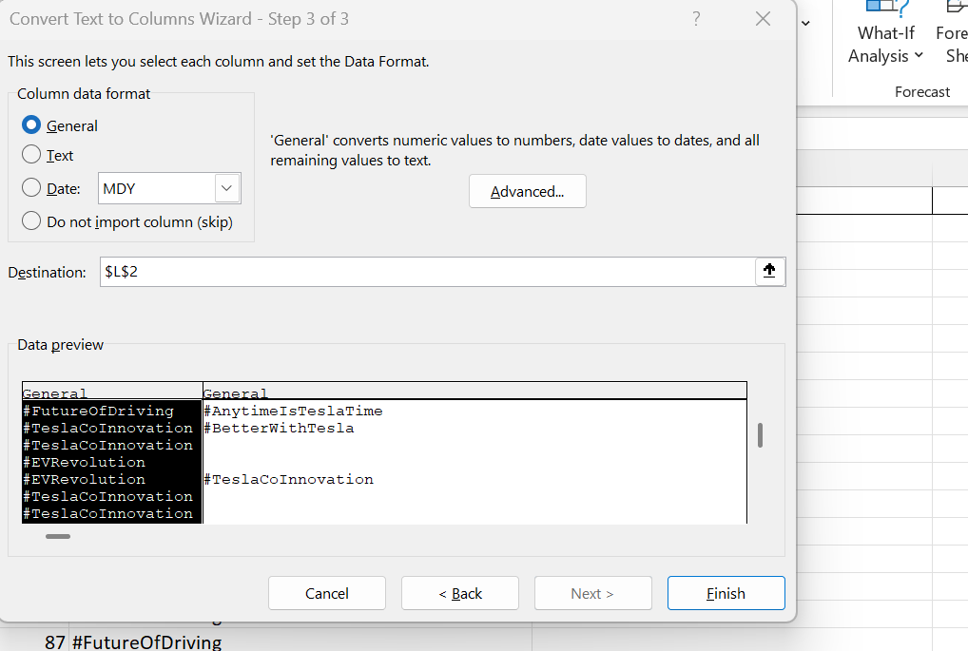
Data ---> Convert Text to Columns. In the second tab give the delimiter as ‘Comma’, in the next tab click ‘Finish’.
For all the 3 sheets, selected ‘All Borders’ and ‘Centre’ alignment. ‘Color Fill’ as Blue Color and ‘Bold’ text for the first row. First row is frozen by using the ‘Freeze Pane’ option.
View ---> Freeze panes.
I have performed the ‘Cell Referencing’ once I have seen the blank values in the Hashtag Split columns.
Formulas ---> Create from Selection ---> Top row.
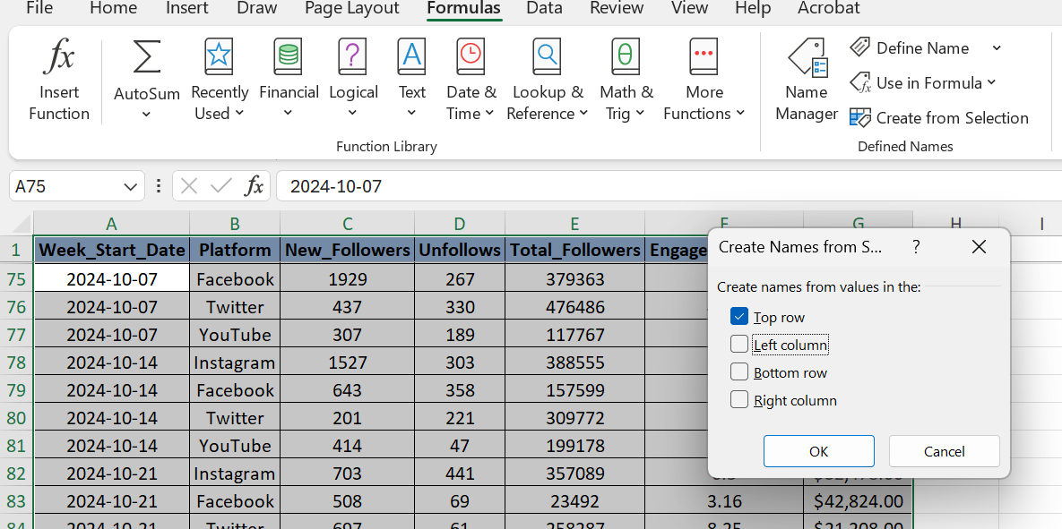

Task 2: Engagement Analysis
Using the Posts Dataset:
● Calculate average engagement rate per platform: Engagement Rate = (Likes + Shares + Comments) / Impressions
First I have created the new column before the reach column. In the new column created the values for the sum of Likes, shares and comments. The column is named as ‘SumLSC’(J Column).
Next, created another colmn, named it as ‘Engagement rate’. The values added are the SumLSC/Impressions. Then multiplied it by 100 and rduced the decimal values to 0.
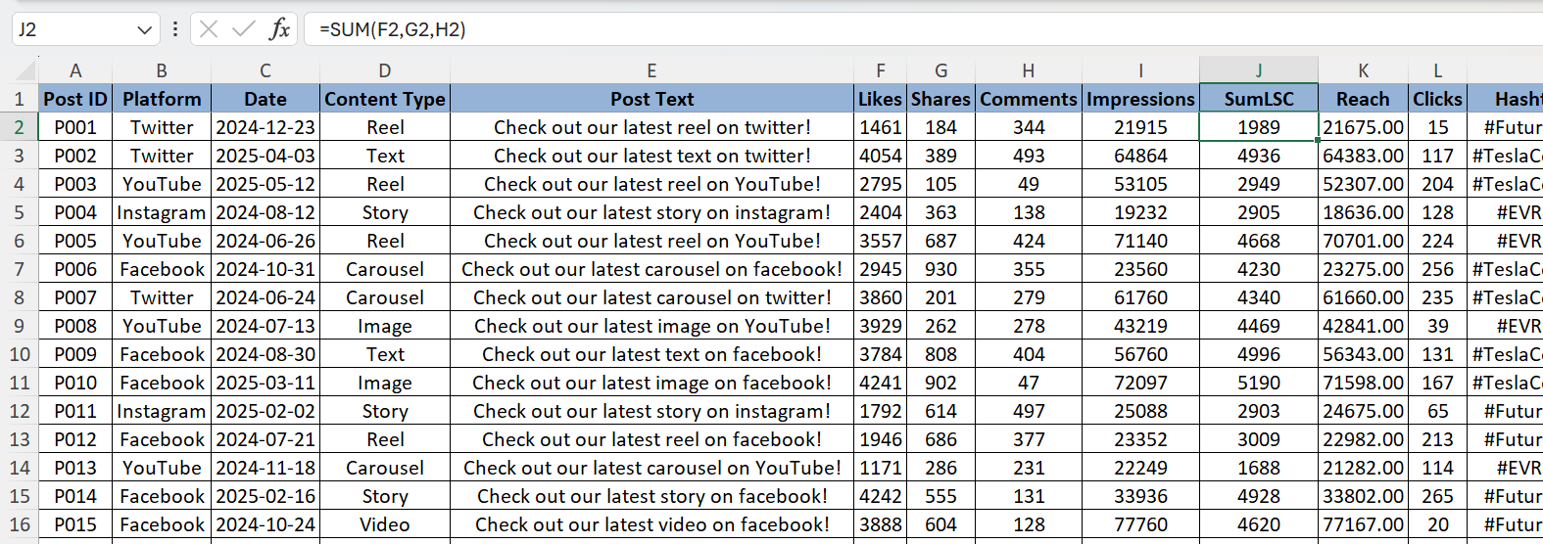
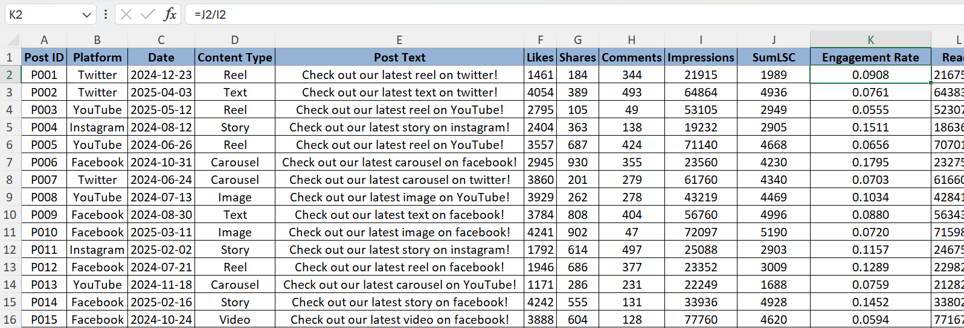
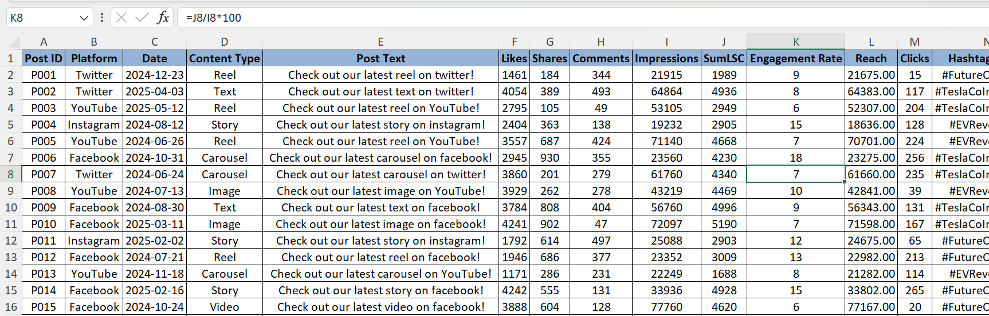
After calculating the engagement rate, create the pivot table by selecting the entire sheet and following the path:
Insert ---> Pivot table ---> From Table/Range. (rows: Platform, Values: Average of Engagement Rate per Platform).
Copy the values to another row below. Then changed the values.
Columns: Content type, Rows: Platform, Values: Average of Engagement Rate per Platform. Then removed the grand total row.
Design ---> Grand Totals ---> Off for Rows and Columns.
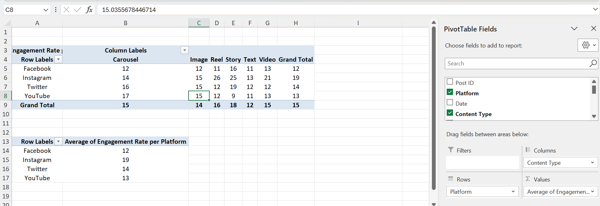
● Identify Top 10 Tesla posts with highest engagement.
Home ---> Sort & Filter ---> Custom Sort (Sort by: Engagement Rate, Sort on: Cell values, Order: Largest to Smallest).
Highlighted the first 10 rows.
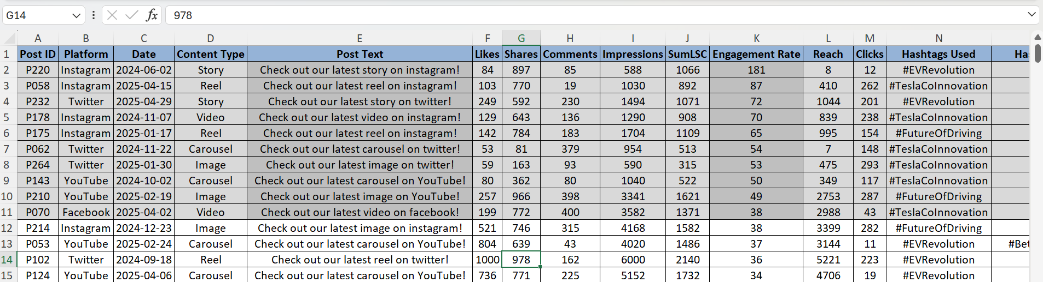
● Create a pivot table showing:
○ Total Likes, Shares, Comments by Content Type & Platform
Insert ---> Pivot table ---> From Table/Range. (rows: Platform, Columns: Content type, Values: Sum of SumLSC).
Copy the values to another row below. Then removed the grand total rows.
Design ---> Grand Totals ---> Off for Rows and Columns.
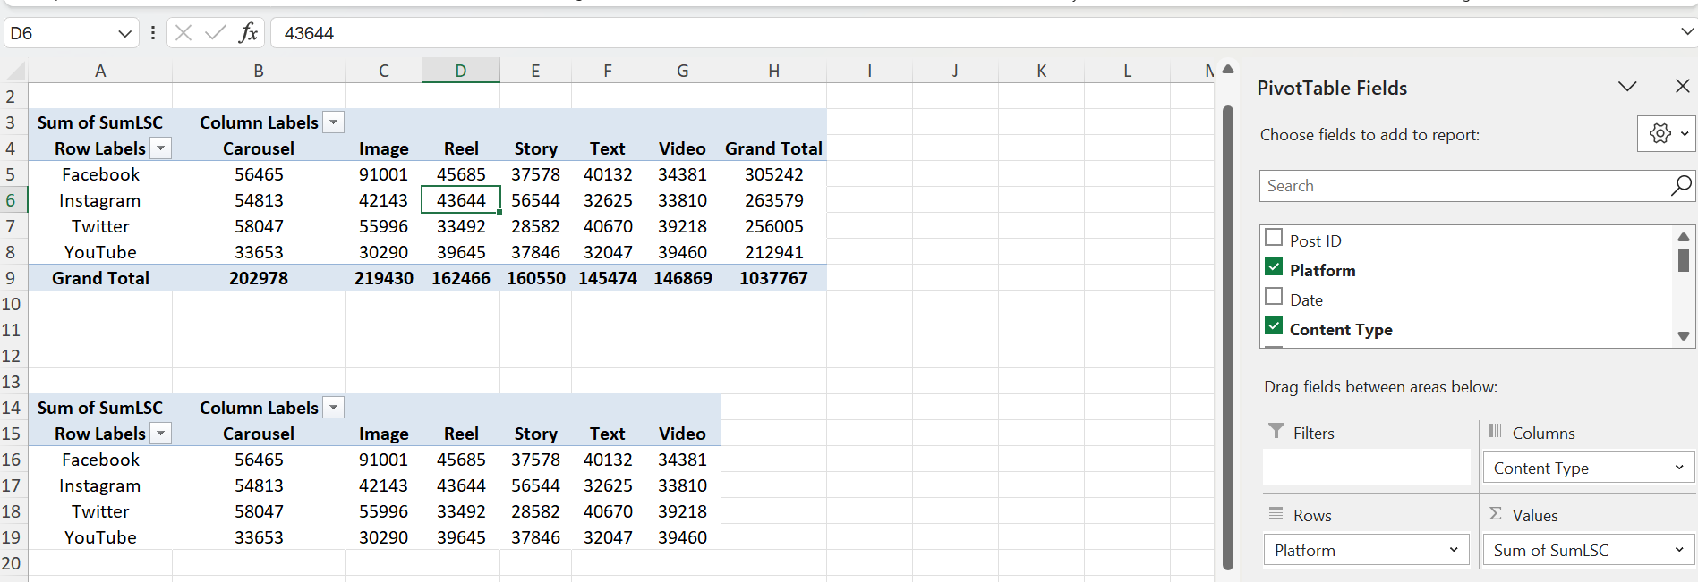
○ Average Clicks per post by Hashtag
Insert the pivot table in another sheet.
Insert ---> Pivot table ---> From Table/Range. (rows: Hashtags Used, Values: Average of Clicks).
Insert another two in the same page and copy into the other page where the other pivot is created.
Insert ---> Pivot table ---> From Table/Range. (rows: Hashtags Split 1, Values: Average of Clicks).
Insert ---> Pivot table ---> From Table/Range. (rows: Hashtags Split 2, Values: Average of Clicks).
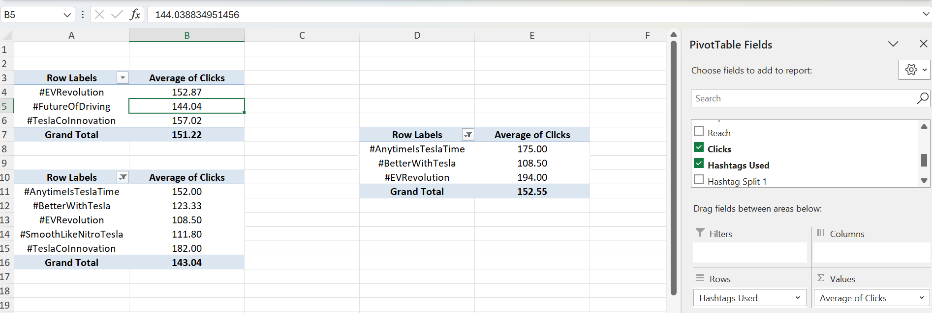

● Highlight top-performing hashtags (#Cybertruck, #ModelY, #EVAdoption, etc.).
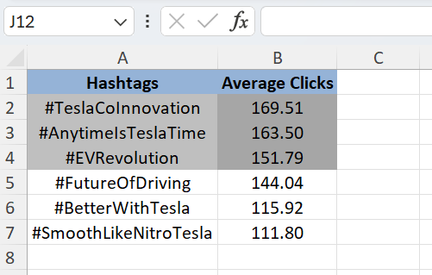
Task 3: Platform Analysis
● Identify the platform with highest engagement (e.g., Twitter for announcements vs. YouTube for product demos).
Insert the pivot table in another sheet.
Insert ---> Pivot table ---> From Table/Range. (rows: Platform, Values: Average of engagement rate).
Then insert another table.
Insert the pivot table in another sheet.
Insert ---> Pivot table ---> From Table/Range. (rows: Platform, Columns: Content type, Values: Average of engagement rate).
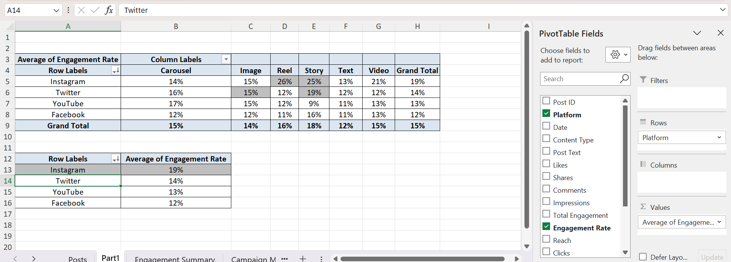

● Compare follower growth rates across platforms.
Created the new column in Engagement Summary – Net gain = New followers - unfollows
Insert the pivot table in another sheet.
Insert ---> Pivot table ---> From Table/Range. (rows: Platform, Values: Sum of Total Followers, Sum of net gain). Then calculated the formula for Growth rate.
Growth Rate: Net gain/total followers*100
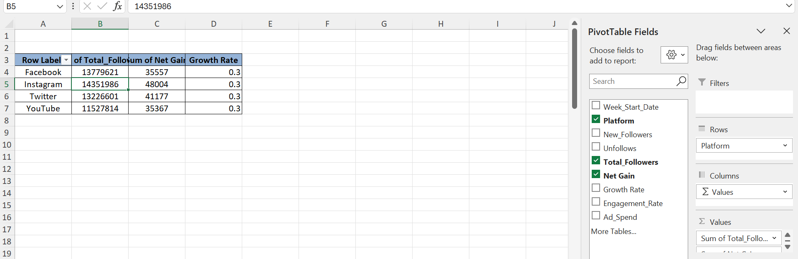
● Visualize Engagement vs. Ad Spend per platform.
Insert the pivot table in another sheet.
Insert ---> Pivot table ---> From Table/Range. (rows: Platform, Values: Engagement rate average, Ad Spend sum). Then calculated the formula for Growth rate.
Insert the Chart into the sheet.Insert ---> Pivot Chart ---> Combo
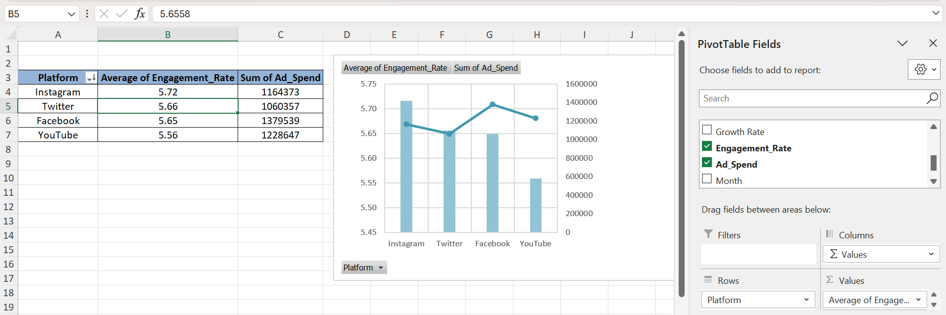
● Advise: Should Tesla focus on Twitter + YouTube (product announcements + demos) or maintain a multi-platform strategy?
Focus should be on Instagram – Avg eng rate is high (5.72 %) and the ad spend is a bit low (1164373) (second smallest).
Next is Twitter – Avg eng rate is second highest (5.66%) and the ad spend is the minimum (1060357) among all.
Task 4: Hashtag & Content Strategy
● Identify most frequently used Tesla hashtags.
Data ---> Get Data ---> From File ---> From Excel Work book (import the workbook from File xplorer).
All the columns from the “Posts” worksheet are selected. Select only Hashtag columns
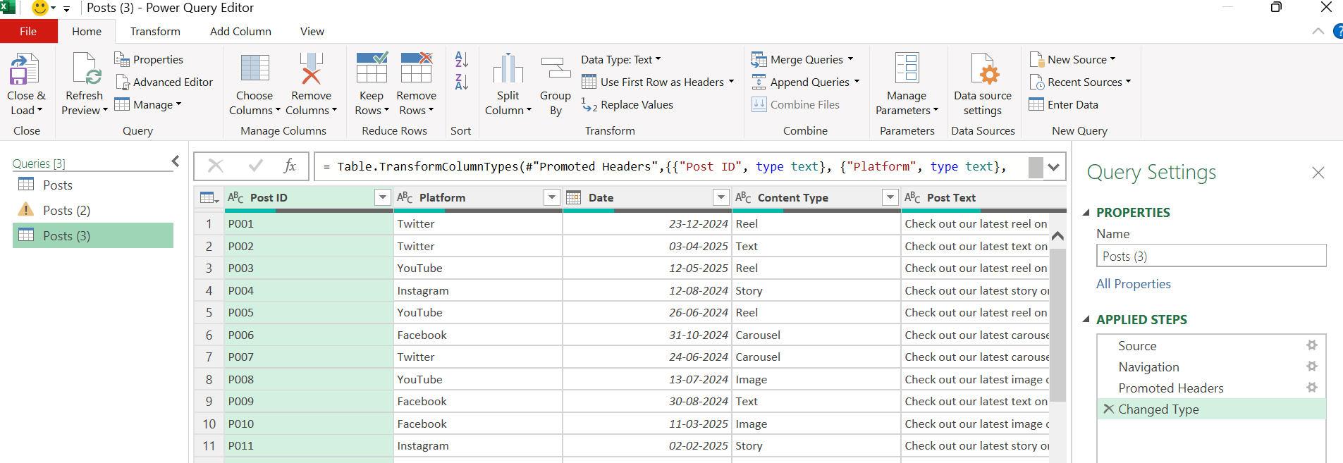
Transform ---> Unpivot columns ---> Only selected Columns (two new columns will be created).
After that Close & Load ---> Close & Load into the sheet. Then the table will be created.
Create the pivot table from the table created from the pivot table.
Insert ---> Pivot table ---> From Table/Range. (rows: Hastags, Values: Post ID sum). Then Sort the post id count by Largest to smallest.
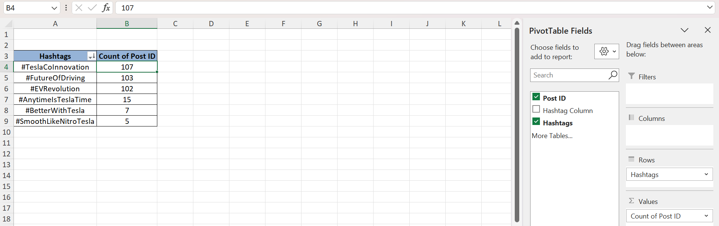
● Compare average performance of posts containing each hashtag.
Create another pivot table from the above created table.
Insert ---> Pivot table ---> From Table/Range. (rows: Hastags, Values: Clicks average, Engagement rate average). Then Sort the Clicks avg with descending order.
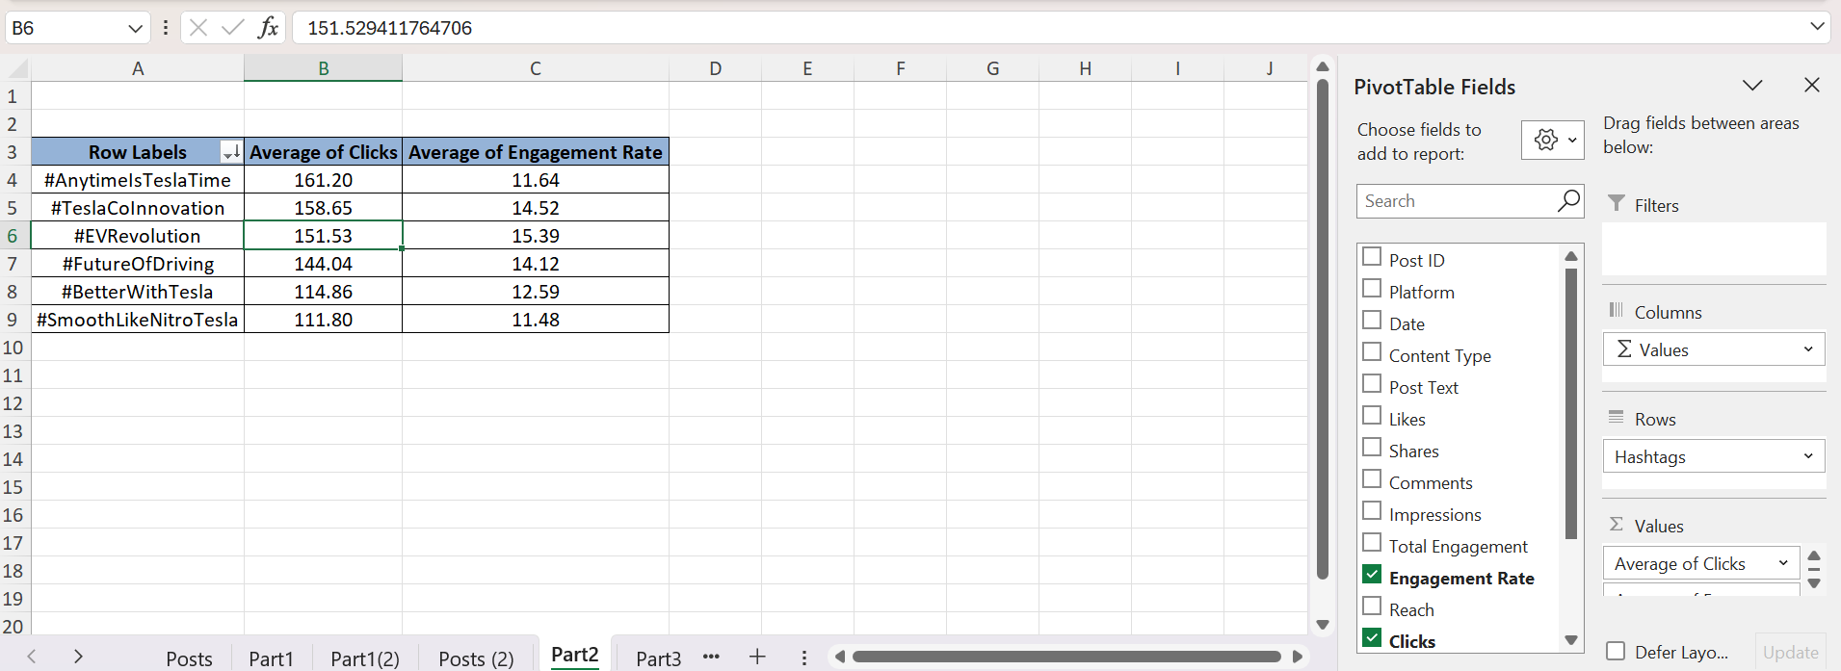
● Compare content performance: ○ Videos (product demos, Elon talks) ○ Images (car designs, interiors) ○ Carousels (features, comparisons)
Then From the original sheet created two pivot tables – one for engagement rate, another for total engagement
Insert ---> Pivot table ---> From Table/Range. (rows: Content type, Columns: Platform, Values: Engagement rate average). Then Sort the Clicks avg with descending order.
Copy the table to another location in the same sheet.
Change the values - rows: Content type, Columns: Platform, Values: Total engagement average.
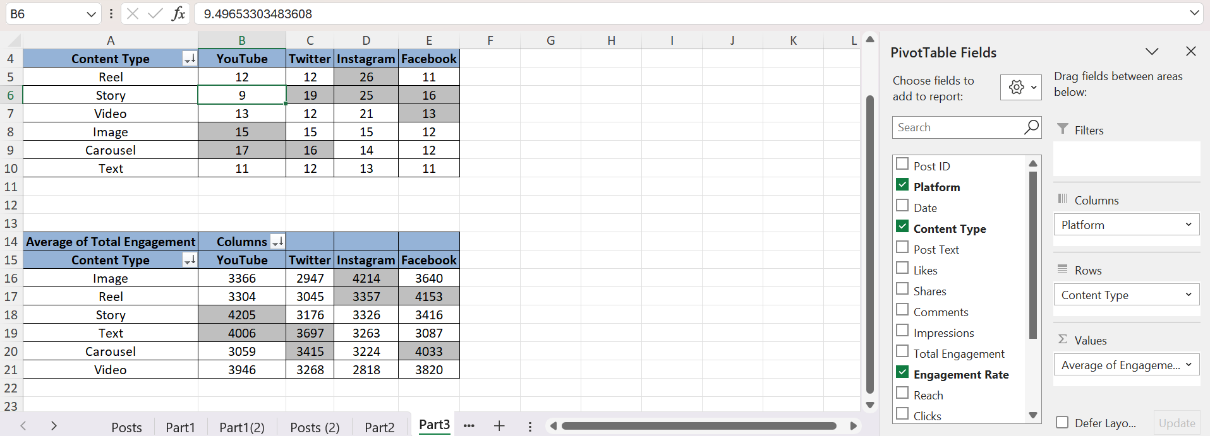
● Recommend content type priorities per platform (e.g., videos on YouTube, car images on Instagram).
Instagram – Engagement rate for Reels (26) & tot engagement for Image (4214).
Twitter – Engagement rate for Story (19) & tot engagement for Text (3697).
YouTube – Engagement rate for Carousel (17) & tot engagement for Story (4205)
Facebook - Engagement rate for Story (16) & tot engagement for Reel (4153).
Instagram – Reels,Image+ Twitter – Story,Text + Yotube – Story.

Task 5: Campaign Effectiveness
● Calculate:
○ Total & Average Impressions, Likes, Clicks per Campaign.
Data ---> Get Data ---> From File ---> From Excel Workbook ---> (Select file from File Explorer).
Transform ---> Unpivot columns ---> Only selected Columns (two new columns will be created).
After that Close & Load ---> Close & Load. Then the table will be created.
Create the pivot table from the above created table.
Insert ---> Pivot table ---> From Table/Range. (rows: Campaigns, Values: Impressions average, Clicks average, Impressions Average).
Create another pivot table from the above created table.
Insert ---> Pivot table ---> From Table/Range. (rows: Campaigns, Values: Impression Count, Clicks count, Impressions count).
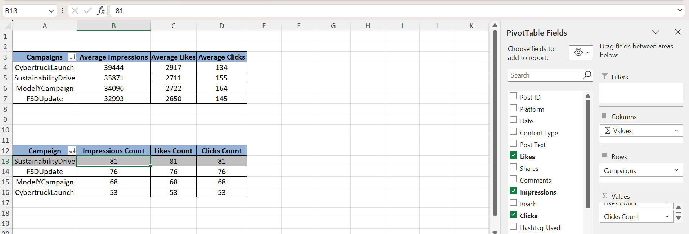

○ Engagement uplift during vs. before campaigns (e.g., Cybertruck launch spike).
Create the pivot table from the above created table.
Insert ---> Pivot table ---> From Table/Range. (rows: Campaigns, Values: Total Engagement Sum).
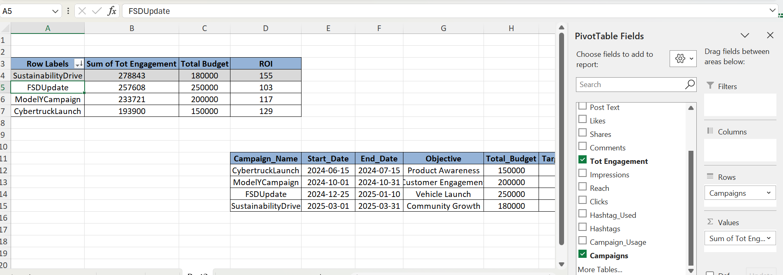
After the pivot table, add an extra field to the table Total Budget. Using the vlookup add the values from the ‘Total budget’ column in ‘Campaign Metadata’. Copied the Entire table to the sheet. Then calculated the ROI.
ROI = total engagement/total budget*100.
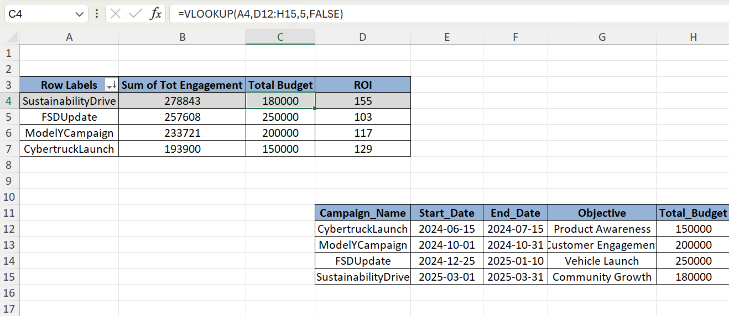
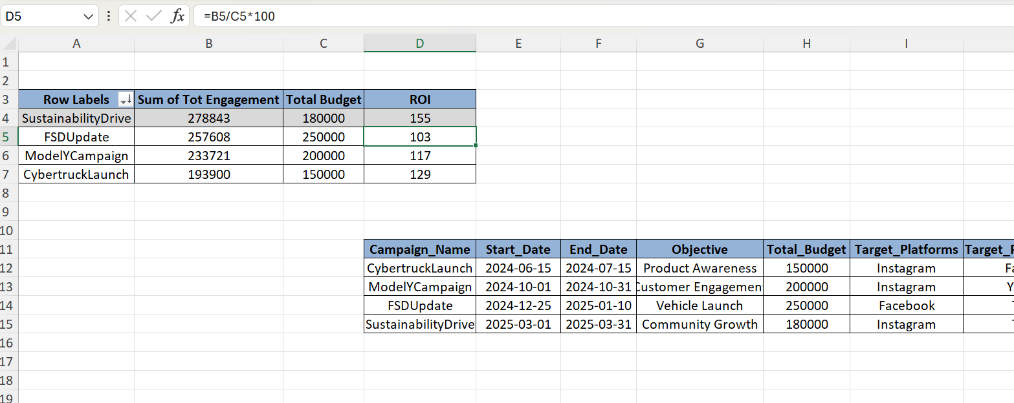
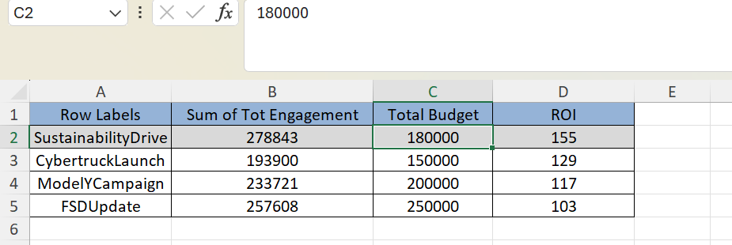
We have converted into the table so that we can sort easily.
We could see the Sum of the total engagement is high for ‘Sustainability Drive’. Where the budget is second minimum, but the ROI is still high.
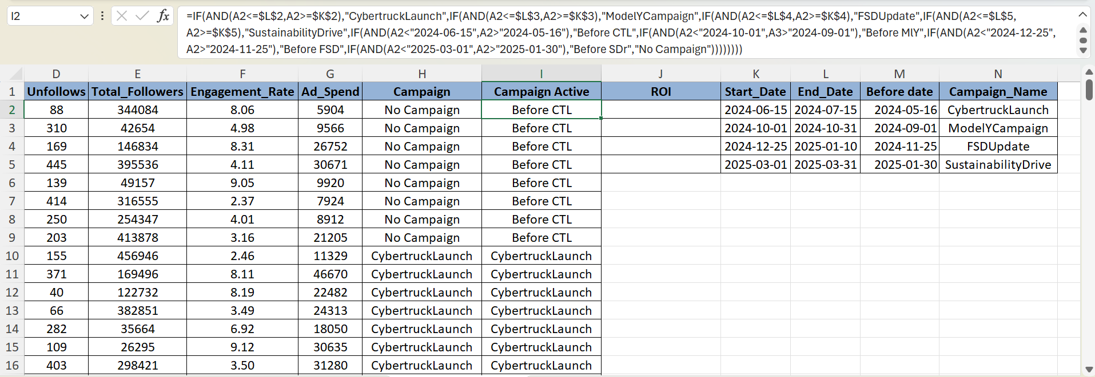
We have created two columns in both ‘Posts’ and ‘Engagement Summary’ from ‘Campaign Metadata’ where we have created the column with no campaign and campaign name along with the ‘week-start-date’ column.
Growth = New followers-Unfollows.
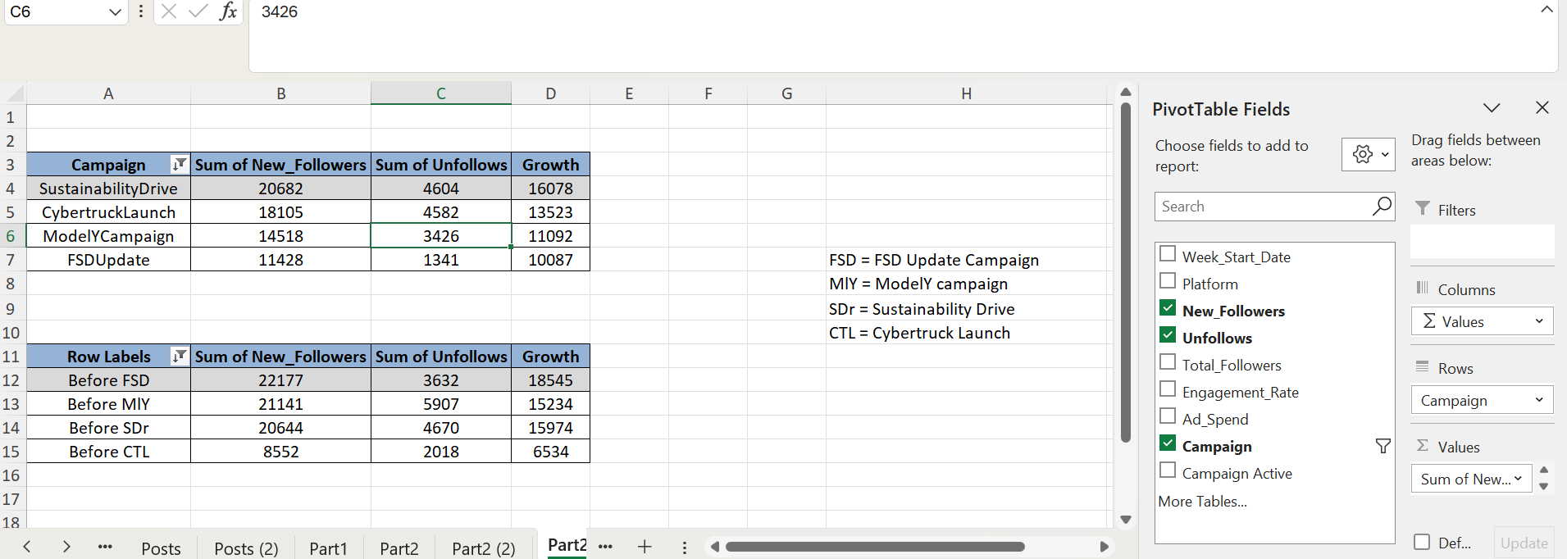
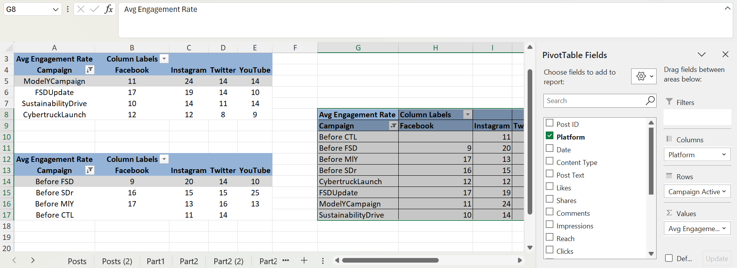
Avg for all the platforms in the row. Then considered the average of all the before rows and all the average rows Growth = AVG(During Camapaigns)-AVG(while campaigns)/AVG(before campaigns). Adjusted the decimals.
● Insights:
○ Which campaign had the highest ROI (engagement vs. spend)?
We could see the Sum of the total engagement is high for ‘Sustainability Drive’. Where the budget is second minimum, but the ROI is still high.
CybertruckLaunch - enagagement is low, budget is minimum, ROI is second highest.
FSDUpdate – engagement is second maximum, budget is second maximum, ROI is second minimum
ModelYCampaign – Enagagement is second minimum, budget is second minimum, ROI is minimum.
ROI – Sustainability Drive, Cybertruck Launch.
Engagement – Sustainability Drive, FSD Update.
Total Budget – FSD Update, ModelyCampaign
○ Which campaign drove the strongest follower growth?
Sustainability Drive is the campaign with maximum follower growth (16078).

Task 6: Follower Retention & Loyalty:
● Visualize weekly follower growth per platform (line chart).
Create the new column ‘net_followers’ with the difference of new followers and unfollows.
Create the pivot table by selecting the data from the selected data from Engagement Summary.
Insert ---> Pivot table ---> From Table/Range. (rows: Week_start_date, Rows: Platform, Values: sum of net_followers).
PivotTable Analyze ---> Pivot Chart ---> Option: Line with markers.
Changed the name of the Chart. Copied the chart into another sheet.
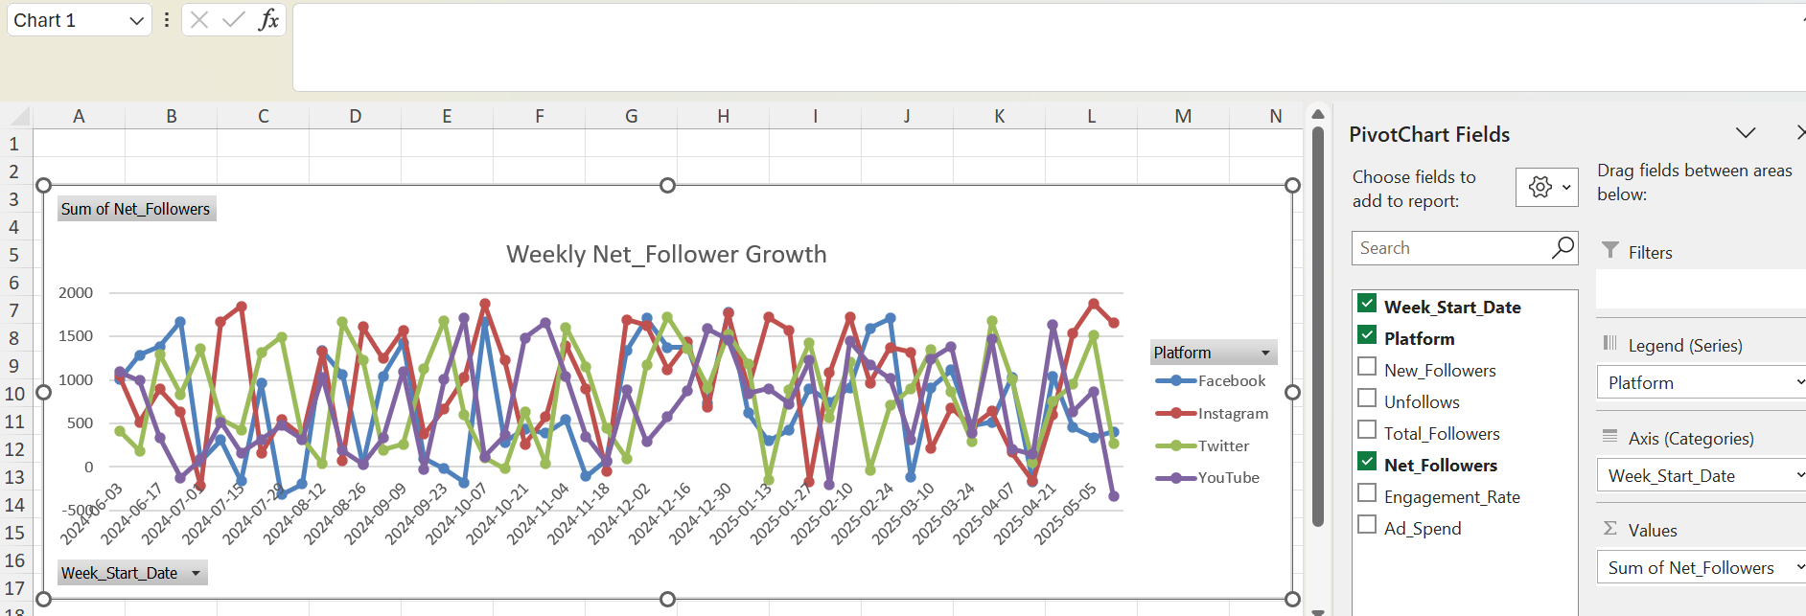
● Identify the peak week of follower gain.
Created the copy of the original sheet. Sorted the Net_followers column into descending order. Highlight the first column. It is the weak with the highest follower gain i.e., 2025-05-05.
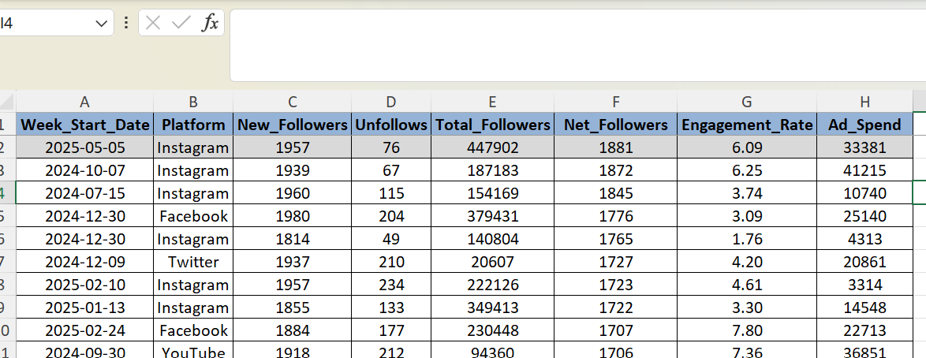
● Use moving averages to smooth growth trends.
Create the copy the first created chart. Right click on any line. In the Add Trndline ---> Moving Average ---> period to 4.
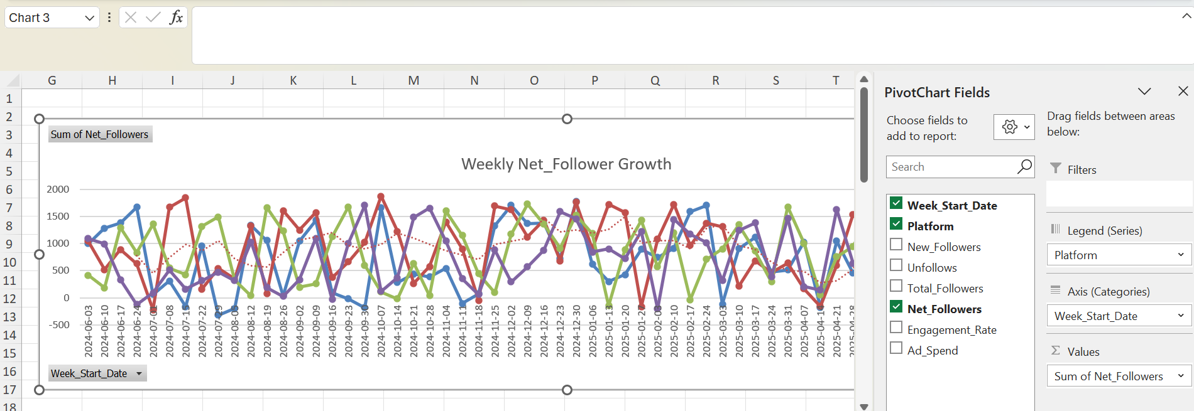
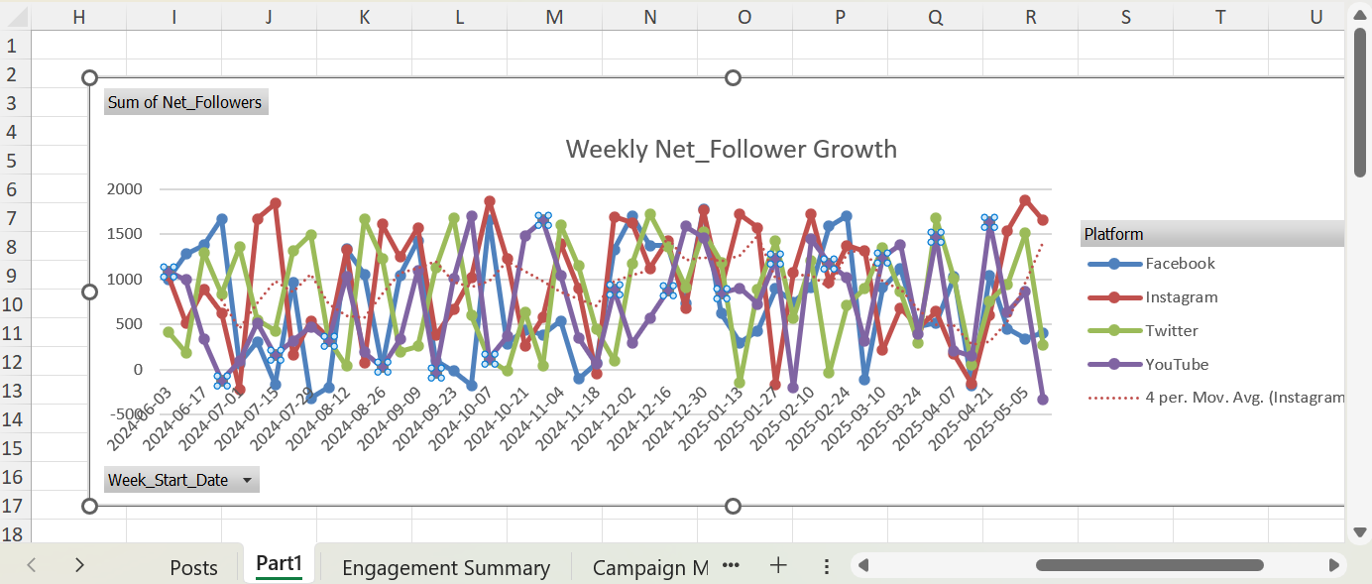
● Correlate ad-spend vs. follower growth using scatter plots.
Create the chart after selecting the Ad_spend and net_Folowers.
Insert chart ---> Scatter plot.
By giving right click, Add a trendline ---> Linear ---> select R-squared value.
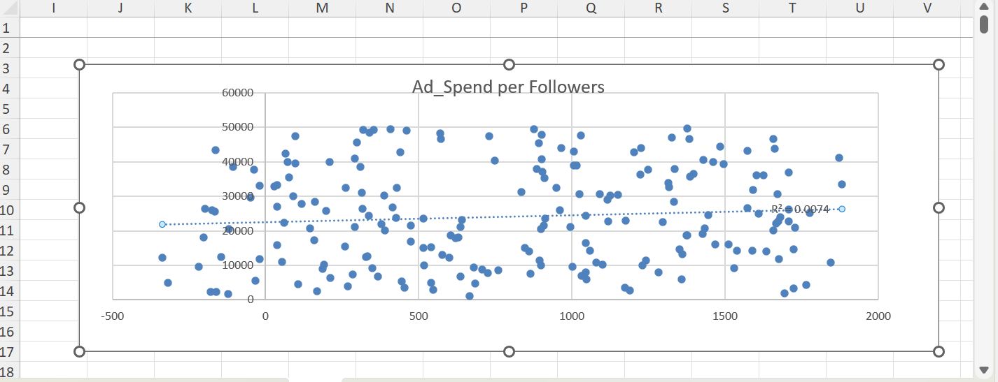

Conclusion:
1)Platform: Focus should be on Instagram – Avg eng rate is high (5.72 %) and the ad spend is a bit low (1164373) (second smallest).
Next is Twitter – Avg eng rate is second highest (5.66%) and the ad spend is the minimum (1060357) among all.
2)Content type & Startegy: Instagram – Engagement rate for Reels (26) & tot engagement for Image (4214).
Twitter – Engagement rate for Story (19) & tot engagement for Text (3697).
YouTube – Engagement rate for Carousel (17) & tot engagement for Story (4205)
Facebook - Engagement rate for Story (16) & tot engagement for Reel (4153).
Instagram – Reels,Image+ Twitter – Story,Text + Yotube – Story.
3)Campaign: We could see the Sum of the total engagement is high for ‘Sustainability Drive’. Where the budget is second minimum, but the ROI is still high.
CybertruckLaunch - enagagement is low, budget is minimum, ROI is second highest.
FSDUpdate – engagement is second maximum, budget is second maximum, ROI is second minimum
ModelYCampaign – Enagagement is second minimum, budget is second minimum, ROI is minimum.
ROI – Sustainability Drive, Cybertruck Launch.
Engagement – Sustainability Drive, FSD Update.
Total Budget – FSD Update, ModelyCampaign
4) Hastags:
#AnytimeIsTeslaTime, #TeslaCoInnovation – the hashtags with the highest clicks.
#TeslaCoInnovation, #FutureOfDriving – has the highest posts.
#EVRevolution, #TeslaCoInnovation – has the highest engagement rate.

